BELL FIRE EQUIPMENT COMPANY

12-14 Yookson Road Picton Industrial Area Po Box 9334 PICTON
Western Australia 6229
PTY LTD
www.bellfire.com.au
Telephone: (08) 9725 6100
Fax: (08) 9725 6105
Email: admin@bellfire.com.au
ABN: 2800 9271 961

Pamphlet No 15
BELL FIREFIGHTER
EQUIPMENT RANGE
September 2022 

BLACKOUT DIFFUSER NOZZLES
AUSTRALIAN MADE RANGE OF DIFFUSER STYLE NOZZLES DEVELOPED AND RUGGEDLY BUILT PREDOMINATELY FOR BUSHFIRE CONTROL.

FITTED WITH A UNIQUE FLOATING DIFFUSER WHICH PREVENTS DEBRIS INDUCED WATER STREAM DISTORTION. BLACKOUTS ARE MOULDED RUBBER OR P.E. BUMP PROTECTED AND HAVE MINIMAL ROTATIONAL TURNS BETWEEN JET / SPRAY FLOW CHARACTERISTICS FOR EASE OF GLOVED HAND USE.

AVAILABLE IN SIZES TO SUIT HOSE REEL AND LAYFLAT USE AND UTILISED IN A VARIETY OF ENGINEERED PRODUCTS SUCH AS PISTOL GRIP NOZZLES, HI-VOLUME MONITOR DISCHARGE, FIXED FIRE PROTECTION DELUGE AND DIRECT COUPLED PLANT WASHDOWN.


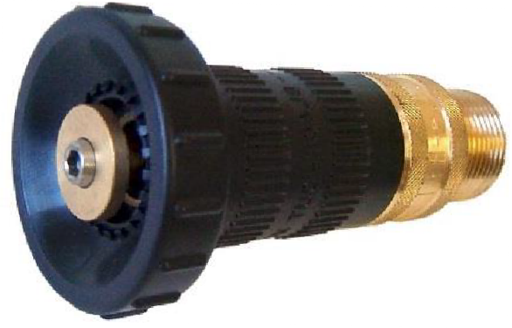
FD/20

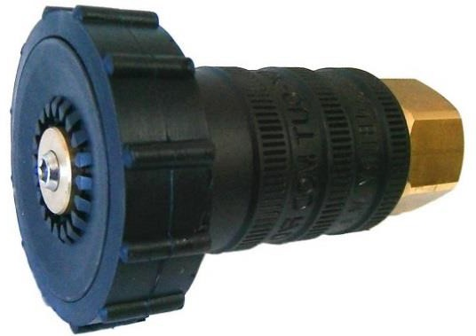
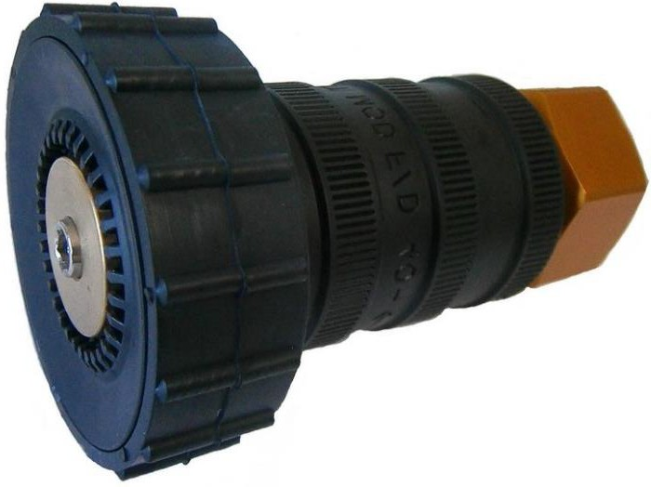
FD/40
FD/25

PISTOL GRIP NOZZLES
See page 3

BLACKOUT NOZZLE PERFORMANCE TESTS
EXPRESSED IN LITRES / MIN AT LISTED PUMP PRESSURES

 | FD/20 @ L/Min |  | FD/25 @ L/Min |  | FD/40 @ L/Min
PRESSURE | JET | FOG | JET | FOG | JET | FOG
5 BAR  75 PSI | 75 | 170 | 85 | 180 | 215 | 450
7 BAR  105 PSI | 90 | 215 | 140 | 270 | 340 | 710
10 BAR  150 PSI | 105 | 245 | 160 | 325 | 410 | 950

NOZZLE SPECIFICATIONS

NOZZLE  (Stock Number) | FD/20  (36840) | FD/25  (36855) | FD/40  (36860)*
OPERATION | 1 x BUMP RING ROTATION | 2/3 BUMP RING ROTATION | 2/3 BUMP RING ROTATION
SPRAY PATTERN | FOG SPRAY/JET/OFF | FOG SPRAY/JET/OFF | FOG SPRAY/JET/OFF
LENGTH | 118mm | 125mm | 158mm
O/A WIDTH | 50mm | 75mm | 100mm
WEIGHT | 0.260kg | 0.580kg | Alum – 0.740kg Brass – 1.850kg
CONNECTING THREAD | - 20mm BSPM  - 20mm Brass adaptor to 20mm BSPF  - 20mm Brass tail | - 25mm BSPF  - 25mm Brass tail  - 25mm / 20mm Brass tail | - 40mm BSPF

MATERIALS

BODY - | UNC MACHINED BRASS BAR STOCK.
SHELL - | INJECTION MOULDED BLACK UHMWPE.
BUMP RING - | BLACK MOULDED RUBBER. (FD/20 – P.E.)
*FD/40 Body available in Brass or Anodised Aluminium

BLACKOUT PISTOL GRIP NOZZLES
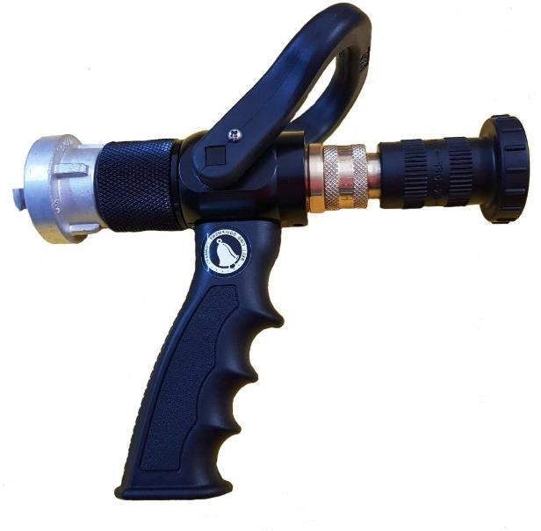
BLACKOUT FD/20 PISTOL GRIP NOZZLE
WITH 25MM SWIVEL WITH STORZ 25MM COUPLING

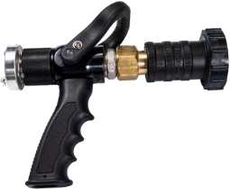
BLACKOUT FD/25 PISTOL GRIP NOZZLE
WITH 25MM SWIVEL / MALE BIC OR STORZ COUPLING (OR ALTERNATIVE)

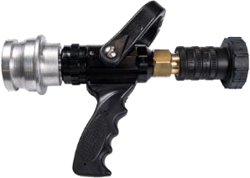
BLACKOUT FD/40 PISTOL GRIP NOZZLE
WITH 40MM SWIVEL / MALE BIC OR STORZ COUPLING (OR ALTERNATIVE)

MATERIALS

BODY - | BLACK ANODISED ALUMINIUM
HANDLE / STIRRUP CONTROL - | INJECTION MOULDED BLACK UHMWPE

